**DAILY ONLINE ACTIVITIES SUMMARY**

|  |  |  |  |  |  |  |  |
| --- | --- | --- | --- | --- | --- | --- | --- |
| **Date:** | **30/05/2020** | | | | **Name:** | **Sheetal** | |
| **Sem & Sec** | **8 B** | | | | **USN:** | **4AL16CS091** | |
| **Online Test Summary** | | | | | | | |
| **Subject** | | **-** | | | | | |
| **Max. Marks** | | **-** | | **Score** | | **-** | |
| **Certification Course Summary** | | | | | | | |
| **Task** | **Course on ethical hacking** | | | | | | |
| **certification** | | | **Udemy** | **Duration** | | | **3 hr** |
| **Coding Challenges** | | | | | | | |
| **Problem Statement:**  1) Find the number that is missing from the array containing n distinct number taken from 0,1,2....n  **.** | | | | | | | |
| **Status:completed** | | | | | | | |
| **Uploaded the report in Github** | | | | **Yes** | | | |
| **If yes Repository name** | | | | [alvas-education-foundation](https://github.com/alvas-education-foundation)/ **[sheetal-shettigar](https://github.com/alvas-education-foundation/sheetal-shettigar)** | | | |
| **Uploaded the report in slack** | | | | **Yes** | | | |

ONLINE TEST

Certification:

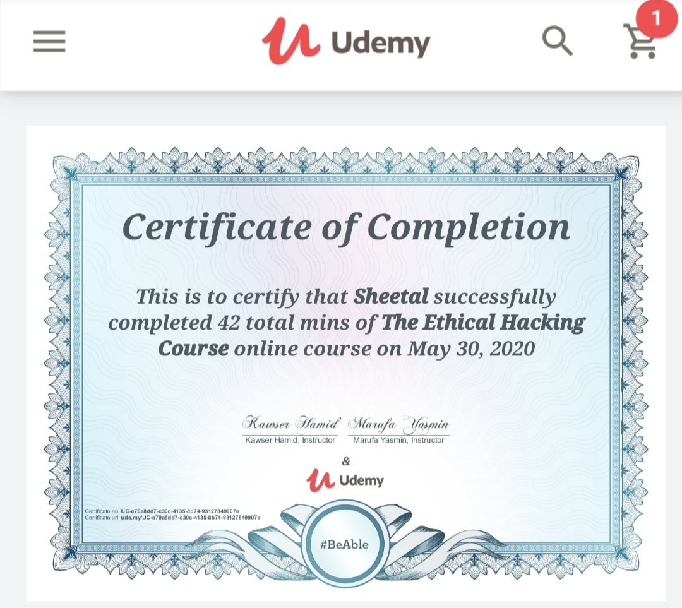

CODING CHALLENGE:

PROGRAM 1 :

#include <stdio.h>

int getMissingNo(int a[], int n)

{

int i, total;

total = (n + 1) * (n + 2) / 2;

for (i = 0; i < n; i++)

total -= a[i];

return total;

}

int main()

{

int a[] = { 1, 2, 4, 5, 6 };

int miss = getMissingNo(a, 5);

printf("%d", miss);

getchar();

}